Chapter 15, Problem 32.

Determine the inverse Laplace transform of each of the following functions:

(a) 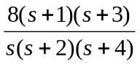
(b) 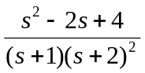
(c) 